UNIVERSITÀ DEGLI STUDI DI SALERNO



INGEGNERIA INFORMATICA MAGISTRALE

Anno scolastico 2023-2024

SOFTWARE ENGINEERING

Gruppo 15

Consegna 19-11-2023

**Sommario**

**1.1.** **Initial product backlog** 3

**1.2.** **Tools setup** 3

**1.3.** **Definition of done** 3

**1.4.** **Design of the architecture** 4

**1.5.** **First sprint planning** 4

* 1. **Initial product backlog**

The user stories are based on the user epics provided by the client. They are presented in an excel file called “ProductBacklog.xlsx”. Each story has an integer ID, a unique name and a priority, where the maximum priority is 1 and the minimum priority is 7. Story points were assigned according to the following scheme:

|  |  |  |  |  |
| --- | --- | --- | --- | --- |
| Story points | Amount of effort required | Amount of time required | Task complexity | Task risk of uncertainty |
| 1 | Minimum effort | Less than an hour | Little complexity | 0/3 |
| 2 | Low effort | Some hours | Little complexity | 0/3 |
| 3 | Mild effort | A day | Low complexity | 1/3 |
| 5 | Moderate effort | Some days | Medium complexity | 2/3 |
| 8 | Severe effort | A week | High complexity | 3/3 |

* 1. **Tools setup**

For better organization, we have a shared Github repository, available at this link:

https://github.com/piezap3/ProgettoSE

and a Trello board, available at this link:

<https://trello.com/b/k0BzBdk9/progettose>

For code we use Java. For IDE we’ve chosen NetBeans. Other tools include JavaFX, JUnit and SceneBuilder.

* 1. **Definition of done**
* All features described in the user story have been implemented;
* All unit tests on single components were successful;
* All integration tests between components were successful;
* All known bugs are fixed
* Code documentation has been updated;
  1. **Design of the architecture**

We’ve chosen MVC architecture for our project:

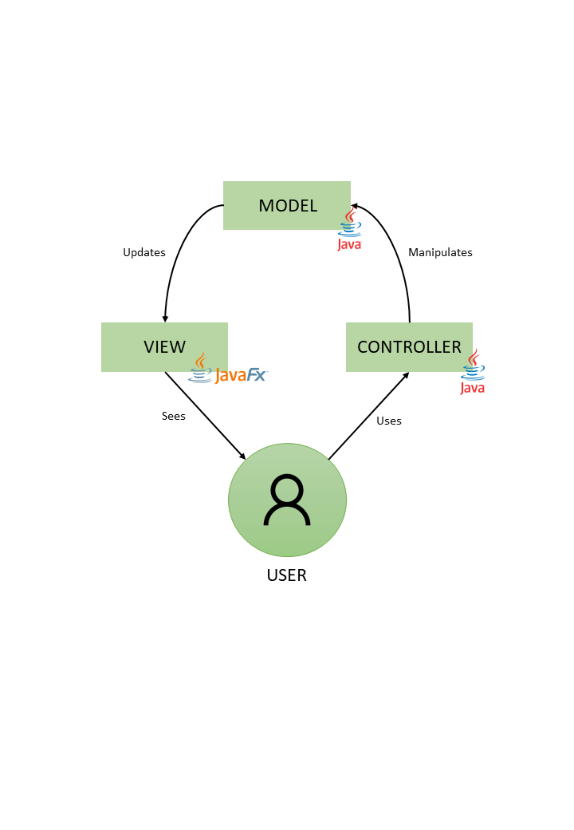

UML class diagram:

* 1. **First sprint planning**

For the first sprint we planned to do user stories from ID 1 to ID 8, for a total extimated velocity of 12.